1.Write a Pandas program to select the distinct department id from employees file.

Code:
import pandas as pd
employees = pd.read_csv("employees.csv")
distinct_departments = employees["department_id"].drop_duplicates()
print(distinct_departments)

Output:
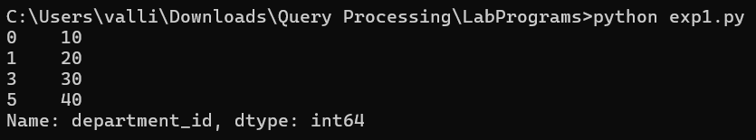

2. Write a Pandas program to display the IDs of employees who have done two or more
Code:
import pandas as pd
job_history = pd.read_csv("job_history.csv")
result = job_history.groupby("employee_id").size()
print(result[result >= 2].index)

Output:

